Ethical, Sustainable and Low Carbon Tissue Sourcing
Low Carbon sourcing is at the heart of all good procurement and sustainability initiatives. Buyers and sustainability officers are increasingly being targeted with low carbon solutions and finding ways to implement low cost, high quality affordable sourcing.

Procurement standards BS 8903 and ISO 26000 track and measure all aspects of organisations ethical, sustainability and low carbon sourcing. Government and global legislation from the Kyoto Protocol and the Paris agreement are being implemented by the Department of Energy and Climate Change and The Environment Agency.

Current UK consumption per head of capita is 110 tissues per year. At hotels, restaurants and venues on average for every 20 customers they will consume one roll of toilet tissue. A department of 1,000 employees will use 810,000 tissues per month. Tissue represents 10% of office consumption.

The carbon used for the manufacture of Virgin Tree sourced tissue is 2grams per sheet so that is 1,620kg of carbon per month or 19.44 tons per year. The equivalent Bamboo is 0.69grams, or 558.9kg of carbon or 6.7 tons per year. For each department of 1,000 people you can save 12.74tons of carbon per year.

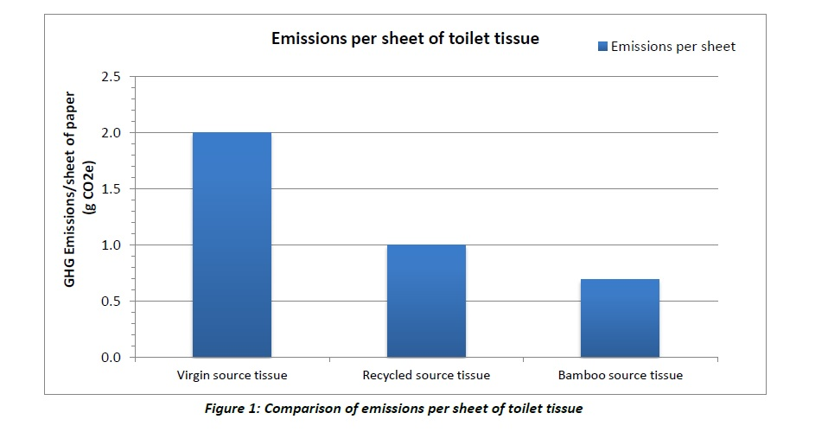

Wholesale branded tissues will cost on average 35p a roll for a total monthly spend of £1,575 for 1,000 employees. The Cheeky Panda wholesale price is 45p a roll so for 1,000 employees the cost is £2,025. Per 1,000 employees you can reduce one ton of carbon for under £450 per month.

Changing from tree tissue to Bamboo can represent a 70% carbon footprint reduction in your tissue range. This measurable change is something that can be added to your annual report and sustainability objectives. Make a difference in the tissue category and be ready for upcoming targets and legislations.

The Cheeky Panda Bamboo Tissue References
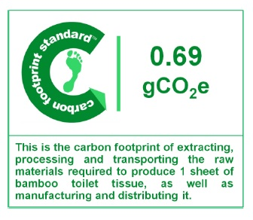 | 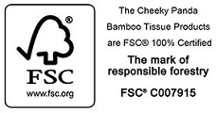

Kyoto Protocol unfccc.int/resource/docs/convkp/kpeng.pdf

Paris Agreement unfccc.int/resource/docs/2015/cop21/eng/l09r01.pdf

The Department of Energy & Climate change: government/publications/evaluation-of-the-carbon

The Environment Agency crc-energy-efficiency-scheme-qualification-and-registration

UK Consumption telegraph.co.uk/news/worldnews/

Unilever unilever.com/sustainable-living

Carbon Footprint Ltd - Sustainability Services For Businesses". radsite.co.uk

51 Facts About Deforestation various-deforestation-facts.php

CO2 Emissions (Metric Tons Per Capita) worldbank.org/indicator

FSC Responsible Procurement fsc-uk.org/en-uk/business-area/procurement

What Can Bamboo Do About CO2? what-can-bamboo-do-about-co2

Sustainable Materials resource/bamboo.html

